

MIND SCAN AI : A MENTAL HEALTH DETECTOR
A PROJECT REPORT
Submitted By
Asha.S [210222104005]
Deepthi.A [210222104009]
Dharshini.K [210222104012]
Hemalatha.R [210222104021]
in partial fulfilment for the award of the degree
of
BACHELOR OF ENGINEERING
IN
COMPUTER SCIENCE AND ENGINEERING
APOLLO ENGINEERING COLLEGE, CHENNAI 601 205
ANNA UNIVERSITY CHENNAI 600 025
MAY 2026

BONAFIDE CERTIFICATE
Certified that this project report “MIND SCAN AI : A MENTAL HEALTH DETECTOR” is the Bonafide work of “ASHA.S [210222104005], DEEPTHI.A [210222104009], DHARSHINI.K [210222104012], HEMALATHA.R [210222104021] who carried out the project work under
my supervision.

SUPERVISOR HEAD OF THE DEPARTMENT

Mrs. R. Sudha, M. Tech., Mrs. R. Sudha, M. Tech.,
Assistant Professor HOD and Assistant Professor
Department of CSE Department of CSE
Apollo Engineering College Apollo Engineering College
Kanchipuram – 602 105 Kanchipuram – 602 105

Submitted to Project and Viva Examination held on …………………

INTERNAL EXAMINER EXTERNAL EXAMINER

ACKNOWLEDGEMENT
We take this opportunity to extend our heartiest thanks to my beloved Vice
Chairman, DR. S PRIYADHARSHINI MBBS, MD, of Apollo Engineering
College for permitting us to do our project.
We extent our thanks to our beloved principal Dr. R. MANOHARAN, M. Tech, Ph.D., for his valuable ideas during our project.
Our sincere thanks to professor and Head of the Department for Suggesting improvement in this module of our project and for proving the necessary climate with her support and encouragement to complete our project work with success.
We are highly indebted and thankful to our internal project guide Mrs. R. SUDHA, M. Tech Head of the Department of CSE for her encouragement and valuable expert guidance throughout the project work.
We are highly Indebted and thankful to all teaching and nonteaching staffs for their encouragement and valuable expert guidance throughout the project work.

ABSTRACT

Mental health has become one of the most critical challenges in modern society, with increasing cases of stress, anxiety, and depression affecting individuals across all age groups. Traditional counseling methods and existing systems often lack automation, continuous monitoring, and accessibility, making them less effective in addressing the growing demand for mental health support. To overcome these limitations, this project introduces. MindScan AI, an intelligent mental health detection system that integrates Artificial Intelligence (AI) and Machine Learning (ML) techniques for early detection, monitoring, and personalized recommendations.The proposed system focuses on automated mood tracking, personalized suggestions, and real-time analysis of user data. By collecting inputs through text, voice, and questionnaires, the system preprocesses data, applies AI/ML algorithms, and generates accurate predictions of mental health status. It identifies emotional patterns, detects risks of stress and depression, and provides actionable recommendations to improve well-being. The system is designed to be userfriendly, accessible on both web and mobile platforms, and suitable for diverse age groups. It ensures data privacy, secure storage, and continuous monitoring, thereby reducing dependency on manual methods and traditional healthcare facilities. MindScan AI offers significant advantages such as efficiency, reliability, and cost-effectiveness compared to conventional approaches. It promotes awareness, supports preventive healthcare, and encourages users to take proactive steps toward emotional stability. Future enhancements may include integration with wearable devices, voice and facial recognition, multilingual support, and clinical applications to further improve accuracy and global accessibility. Overall, this project demonstrates the potential of combining psychology with advanced computing technologies to deliver a smart, comprehensive, and scalable solution for mental health detection and management.

TABLE OF CONTENTS

S.NO TITLE PAGE.NO.
ABSTRACT 4
1. INTRODUCTION 10
1.1 Artificial Intelligence (AI) 11
1.2 Machine Learning (ML) 11
1.3 Role of AI/ML in Mental Health Detection 12
1.4 Scope of the project 13
2. EXISTING SYSTEM AND ITS 14
LIMITATION
2.1 Traditional Counselling and Therapy 14
2.2 Separate Mental Health Apps 14
  - Disadvantages 15
3. PROPOSED SYSTEM AND ITS 16
ADVANTAGES
3.1 Automated Mood Tracking 16
3.2 Personalized Recommendations 16
3.3 Advantages 17

S.NO TITLE PAGE NO.

4. HARDWARE AND SOFTWARE 18
REQUIREMENTS
4.1 Hardware Requirements 18
4.2 Software Requirements 18
5. HARDWARE AND SOFTWARE 19
REQUIREMENTS DESCRIPTIONS

6. LITERATURE SURVEY 26

6.1 Intelligent Depression Prevention via LLM-Based 26

Dialogue Analysis
6.2 Explainable AI for Depression Detection 27
Activity Data
6.3 Multi-Modal LLM for Depression Detection 27
6.4 Advances in AI-Based Depression Diagnosis: 28
Systematic Review
6.5 AI-Based Screening Through Eye Tracking 29
7. SYSTEM ARCHITECTURE 30
7.1 System Architecture Diagram 30
7.2.Flow chart 31

S.NO TITLE PAGE NO.

8. DATA FLOW DIAGRAM 32
8.1 Work flow Diagram 32
8.2 Data Flow Diagram 33
  - Use Case Diagram 33
8.4Class Diagram 34
8.5Activity Diagram 35
8.6 Sequence Diagram 36
8.7 ER Diagram 36
8.8 Collaboration Diagram 37
9. MODULES 38
9.1 User Interface Module 38
9.2 Input Module 38
9.3 Data Preprocessing Module 39
9.4 AI/ML Analysis Module 39
9.5 Prediction Module 40
9.6 Recommendation System Module 40
9.7 Database / Cloud Storage Module 40
10. OUTPUT 41
11. CONCLUSION 46
12. FUTURE ENHANCEMENT 47
13. APPENDICES 49
13.1 Coding 49
14. REFERENCES 54

LIST OF FIGURES

FIGURE NO TITLE PAGE NO
1 ARCHITECTURE DIADRAM 30
2 DATA FLOW DIAGRAM 33
3 USE CASE DIAGRAM 33
4 CLASS DIAGRAM 34
5 ACTIVITY DIAGRAM 35
6 SAMPLE OUTPUT 41-45

LIST OF ABBREVIATION

AI - Artificial Intelligence
ML - Machine Learning
NLP - Natural Language Processing
SVM - Support Vector Machine
RF - Random Forest
UI - User Interface
SQL - Structured Query Language
HTML - Hyper Text Markup Language
CSS - Cascading Style Sheets
JS - JavaScript
GUI - Graphical User Interface
DBMS - Database Management System
NB - Naïve Bayes
DL - Deep Learning
CNN - Convolutional Neural Network
LR - Logistic Regression

CHAPTER 1

1.INTRODUCTION

Mental health is a vital aspect of human life, influencing how individuals think, feel, and behave in daily situations. In today’s fast-paced world, stress, anxiety, and depression have become common due to academic pressure, work stress, and personal challenges. Unfortunately, mental health problems are often not identified at an early stage, as people hesitate to consult doctors or fail to recognize their emotional condition. Traditional detection methods, such as questionnaires and clinical consultations, are time-consuming, subjective, and lack continuous monitoring.
To address these challenges, “MindScan AI” has been developed as an intelligent mental health detection system. The platform leverages Artificial Intelligence (AI) and Machine Learning (ML) to analyze user emotions through text, voice, and activity inputs. Using algorithms such as Naïve Bayes, Support Vector Machine (SVM), Logistic Regression, and Random Forest, the system detects early signs of mental health issues and provides real-time analysis.
MindScan AI offers personalized suggestions, mood tracking, and self-assessment tools, while ensuring data privacy and security. It connects users to counseling resources when needed and promotes early detection and prevention of serious conditions. Designed with modern technologies such as Python and web frameworks, the system integrates multiple modules to deliver insights through charts, reports, and timely alerts. Accessible via web and mobile applications MindScan AI acts as a digital mental health assistant, supporting individuals of all age groups inmaintaining emotional balance and improving overall well-being.

1.1 ARTIFICIAL INTELLIGENCE (AI)

Artificial Intelligence (AI) is a branch of computer science that focuses on creating machines capable of performing tasks requiring human intelligence, such as learning, decision-making, and problem-solving. AI systems analyze large amounts of data, identify patterns, and use algorithms to process information efficiently.
In healthcare, AI supports diagnosis, early disease detection, and treatment planning. It works continuously without fatigue, reduces human effort, and improves accuracy.
In MindScan AI, Artificial Intelligence plays a central role. It analyzes user emotions through text and voice inputs, identifies stress, anxiety, and depression, and provides real-time insights. Using Natural Language Processing (NLP), AI understands human communication and generates personalized recommendations. Over time, AI learns from past data, improving prediction accuracy and reliability.
Overall, AI acts as the “brain” of MindScan AI, ensuring efficient mental health detection, timely feedback, and better user experience. It demonstrates the power of modern technology in solving real-world health and challenges.

1.2 MACHINE LEARNING (ML)
Machine Learning (ML) is a subset of Artificial Intelligence that enables systems to learn from data and improve performance without explicit programming for every task. ML algorithms analyse datasets, identify patterns, and make predictions, becoming more accurate over time.
are three main types of ML: supervised learning, which uses labelled data; unsupervised learning, which discovers hidden patterns;and reinforcement learning, which improves decisions through trial and error. ML is widely applied in recommendation systems, fraud detection, and healthcare.
In MindScan AI, Machine Learning plays a key role in classifying emotional states and predicting mental health conditions. Algorithms such as Naïve Bayes, Support Vector Machine (SVM), Logistic Regression, and Random Forest are used to analyze user inputs and detect stress, anxiety, and depression. These models provide real-time analysis, risk level identification, and personalized suggestions.
Overall, ML enhances the intelligence of MindScan AI by ensuring accurate predictions, adapting to new data, and supporting continuous improvement in mental health detection.

1.3 ROLE OF AI & ML IN MENTAL HEALTH DETECTION

Artificial Intelligence (AI) and Machine Learning (ML) play a crucial role in modern mental health detection. The system collects data from multiple sources such as text, voice, and activity inputs. AI processes this information to understand emotions, while ML models identify patterns and classify conditions.

Natural Language Processing (NLP) is used to analyze user messages, detect emotional keywords, and perform sentiment analysis. This helps in identifying stress, anxiety, and depression levels. ML algorithms further calculate risk scores, categorizing users into low, medium, or high-risk groups.
AI provides real-time feedback and personalized recommendations, while ML continuously improves accuracy by learning from user data. Together, they enable early detection, continuous monitoring, and timely intervention. The system also ensures data privacy, secure processing, and efficient handling of large datasets.
Overall, AI and ML form the core of MindScan AI, making mental health detection smart, reliable, and accessible for users of all age groups.

1.4 SCOPE OF THE PROJECT
The scope of MindScan AI is to provide an intelligent, automated platform for mental health monitoring and support. The system is designed to address the limitations of traditional methods by offering continuous, real-time analysis and personalized guidance. Its key features include:
- Online platform for mental health monitoring
- Mood and stress tracking with regular updates
- Self-assessment tools for early detection of issues
- Personalized suggestions and wellness tips
- Access to counselling resources and helplines
- Secure and private data management
By integrating Artificial Intelligence and Machine Learning, the project ensures accurate detection of emotional states, timely feedback, and improved accessibility for users of all age groups. The scope emphasizes innovation in healthcare technology, combining psychology and computer science to promote early detection, prevention, and better mental well-being.

CHAPTER 2
2.EXISTING SYSTEM AND LIMITATIONS

2.1 TRADITIONAL COUNSELING AND THERAPY
Traditional counseling is a widely used method for mental health care. It involves direct communication with trained professionals, usually through face-to-face sessions in clinics or hospitals. Therapy helps patients understand emotional and psychological issues, with doctors providing guidance and treatment plans.
Sessions may be scheduled weekly or monthly depending on the patient’s condition.
While reliable, this method requires physical presence and can be costly. Many individuals hesitate to share personal problems, and appointments may not always be available immediately. Continuous monitoring is not possible, progress tracking is difficult, and immediate support is limited. It is not suitable for remote areas or large populations, and scalability is poor. Overall, traditional counseling has several limitations in modern healthcare, highlighting the need for automated and accessible solutions.

2.2 SEPARATE MENTAL HEALTH APPS
Many mental health apps are available today, offering basic support such as mood tracking, meditation exercises, and self-help content. These apps are accessible anytime, simple to use, and widely supported on mobile platforms. They provide convenience and flexibility for users.
However, most apps work independently and provide only limited features. Users often need multiple apps for complete support, reducing convenience. Data is not integrated across platforms, personalization is weak, and real-time analysis is missing. Many apps require paid subscriptions, while free versions offer restricted access. Privacy and security are not always guaranteed, and medical validation is often lacking. Continuous monitoring and engagement are limited, making them unsuitable for serious mental health issues. Overall, separate apps fail to provide a comprehensive solution.

2.3 DISADVANTAGES OF EXISTING SYSTEMS
Existing systems face several disadvantages that limit their effectiveness. They are not fully automated, rely heavily on manual processes, and are time-consuming. Traditional methods require physical presence, lack continuous monitoring, and do not track daily changes in mental health. Personalization is minimal, and users rarely receive customized suggestions.
Accessibility is another major issue, especially in rural areas where facilities are scarce. Social stigma prevents many from seeking help, while privacy and data
security concerns remain common. Systems are fragmented, detection accuracy is low, and early intervention is difficult. Real-time analysis and immediate feedback are missing, and user engagement is poor due to non-interactive interfaces. Scalability is limited, large datasets are not handled efficiently, and advanced AI usage is minimal. Overall, existing systems do not meet modern healthcare needs, reinforcing the importance of innovative solutions like MindScan AI.

CHAPTER 3
3.PROPOSED SYSTEM

3.1 AUTOMATED MOOD TRACKING
The proposed system introduces automated mood tracking to record user emotions daily through text or voice inputs. Emotional data is collected continuously and analyzed by AI to identify mood patterns over time. The system detects both positive and negative emotions, provides instant feedback, and stores daily records for future reference. Charts and graphs display emotional changes clearly, helping users track fluctuations and progress. Alerts are generated for negative trends, encouraging timely action. This feature is simple, user-friendly, and works continuously in the background, ensuring accurate and smart mood tracking.

3.2 PERSONALIZED RECOMMENDATIONS
MindScan AI provides personalized recommendations based on user data and behavior. AI analyses emotional patterns and generates customized advice, including stress relief techniques, meditation, relaxation exercises, and motivational messages.
Suggestions adapt dynamically to user moods, improving engagement and promoting healthy habits. Recommendations are simple, practical, and delivered in real-time, supporting quick decision-making and self-care practices. Over time, the system learns from user history, enhancing the quality of guidance. This feature ensures users feel supported, motivated, and guided toward better emotional stability and mental well-being.

3.3 ADVANTAGES
The proposed system offers several advantages over existing methods. It provides real-time monitoring, instant feedback, and early detection of mental health issues. Fully automated, it reduces manual effort while AI and ML improve accuracy and performance. Personalized recommendations ensure customized support, and the platform is user-friendly, accessible via both web and mobile applications. Suitable for all age groups, it ensures continuous monitoring, secure data management, and cost-effective healthcare. Users save time and effort compared to traditional consultations, while accessibility is improved for remote areas. The system promotes preventive healthcare, reduces risks of severe conditions, and enhances overall user experience. MindScan AI thus delivers an efficient, smart, and complete mental health solution.

CHAPTER 4
- HARDWARE AND SOFTWARE REQUIREMENTS.
4.1 HARDWARE REQUIREMENTS
The system requires basic hardware components.
- Computer or laptop.
- Processor -Intel Core i3 or above.
- RAM -at least 8GB.
- Hard disk -minimum 10GB free space.
- Internet connection .
- Keyboard and mouse are required for input.
- A microphone .
4.2 SOFTWARE REQUIREMENTS
- The system requires specific software tools.
- Operating system -Windows or Linux.
- Python.
- Libraries- NumPy and Pandas.
- Scikit-learn.
- Natural Language Processing.
- Frontend -HTML, CSS, and JavaScript.
- React.js.
- Node.js and Express.js
- MySQL Database
- Visual Studio Code

CHAPTER 5
HARDWARE AND SOFTWARE REQUIREMENTS

5.1 HARDWARE REQUIREMENTS DESCRIPTION

5.1.1 PC or Laptop
A personal computer or laptop serves as the primary hardware platform for developing and running MindScan AI. It provides the computational power needed to execute Python scripts, run machine learning models, and host the web-based interface locally. A laptop is especially useful as it offers portability, allowing the system to be developed, tested, and demonstrated in different environments including classrooms, labs, or clinical settings. Modern laptops come equipped with multi-core processors, sufficient RAM, and fast storage that collectively support smooth execution of AI-based applications without requiring specialized hardware.

5.1.2 Processor – Intel Core i3 or Above
The processor is the brain of the system and determines how fast computations are carried out. MindScan AI requires a minimum Intel Core i3 processor or equivalent to handle the execution of Python scripts, machine learning inference, and web server operations. An Intel Core i5 or higher is recommended for training machine learning models efficiently. Higher clock speeds and multiple cores allow the system to process natural language inputs, run sentiment analysis algorithms, and serve multiple users concurrently without noticeable delays. Modern processors also support hardware-level security features that help protect sensitive mental health data.

5.1.3 RAM – Minimum 8GB
Random Access Memory (RAM) plays a critical role in the smooth execution of MindScan AI. A minimum of 8GB RAM is required to load machine learning libraries such as TensorFlow, Scikit-learn, and NLTK simultaneously without system slowdowns. RAM holds the active data during processing, including user inputs, trained model weights, and intermediate computation results. With higher RAM capacity of 16GB or above, the system can handle more concurrent users, process larger datasets, and run complex Natural Language Processing (NLP) models without performance degradation. Insufficient RAM causes the system to rely on virtual memory, which significantly slows down processing and affects user experience.

5.1.4 Hard Disk – Minimum 10GB Free Space
Adequate storage is required to save datasets, trained model files, user records, log files, and software dependencies. A minimum of 10GB free disk space ensures that all necessary files including Python environment packages, MySQL database files, and project source code can be stored efficiently. Using an SSD (Solid State Drive) instead of a traditional HDD further improves data read and write speeds, resulting in faster application startup, quicker model loading times, and more responsive database queries. SSDs also provide better reliability and durability compared to spinning disk drives, which is important for systems handling sensitive healthcare data.

5.1.5 Internet Connection
A stable broadband internet connection is required for MindScan AI to support online user access, cloud data synchronization, and real-time API communication. The internet connection enables the system to connect users across different geographic locations to the central server, allowing seamless mood tracking and mental health monitoring from any device. A minimum speed of 10 Mbps is recommended for smooth operation. High-speed internet also enables timely updates to the AI models, integration with third-party mental health resources, and fast delivery of personalized recommendations to users without latency issues.

5.1.6 Microphone and Audio Devices
MindScan AI supports voice-based input as one of its primary data collection methods. A built-in or external microphone is required to capture voice inputs from users for speech-based mood assessment. The system uses Natural Language Processing and speech recognition libraries to convert spoken words into text, analyze the emotional tone, and determine the mental health status of the user. Highquality audio input improves the accuracy of speech recognition, especially in environments with backgro und noise. Audio devices also play a role in delivering audio-based feedback or mental wellness reminders to users through text-to-speech functionality.

5.2 SOFTWARE REQUIREMENTS DESCRIPTION

5.2.1 Operating System – Windows or Linux
Windows 10 or Windows 11 is the recommended operating system for MindScan AI as it provides broad compatibility with development tools, Python environments, MySQL servers, and web frameworks. Windows offers a user-friendly graphical interface that simplifies project setup and debugging. It supports all required libraries and IDEs out of the box, making it the preferred choice for development and testing. Linux (specifically Ubuntu 20.04 LTS or later) is an excellent alternative for server-side deployment due to its superior stability, built-in security features, and open-source nature. Linux also performs better in resource-constrained environments and is widely adopted for cloud server deployments where MindScan AI would be hosted for production use.

5.2.2 Python
Python is the core programming language used throughout MindScan AI for backend development, data processing, and machine learning model implementation. Python is chosen for its simplicity, clean syntax, and an extensive ecosystem of libraries specifically designed for Artificial Intelligence, Machine Learning, and Natural Language Processing. It allows rapid prototyping and seamless integration between the AI analysis engine and the web-based frontend. Python version 3.8 or above is recommended. Its interpreted nature makes debugging and testing faster during development, while its compatibility with frameworks like Flask and FastAPI makes it ideal for building scalable REST APIs that power the MindScan AI backend services.

5.2.3 NumPy and Pandas
NumPy and Pandas are two fundamental data science libraries used extensively in MindScan AI for data manipulation and analysis. NumPy provides support for large multi-dimensional arrays and matrices, along with a rich collection of mathematical functions to operate on them. It is used for numerical computations during AI model training and prediction. Pandas provides powerful data structures such as DataFrames that simplify loading, cleaning, and transforming structured datasets. In MindScan AI, Pandas is used to handle user mood tracking data, preprocess questionnaire responses, manage CSV-format datasets, and perform statistical analysis on historical mental health records to identify behavioral patterns and trends over time.

5.2.4 Scikit-learn
Scikit-learn is the primary machine learning library used in MindScan AI for training classification and prediction models. It provides a wide range of supervised and unsupervised learning algorithms including Logistic Regression, Random Forest, Support Vector Machine (SVM), Decision Trees, and K-Nearest Neighbors (KNN). These algorithms are used to classify user mental health states such as normal, mild stress, moderate depression, or severe anxiety based on their input data. Scikit-learn also provides tools for model evaluation including accuracy scoring, confusion matrix generation, cross-validation, and hyperparameter tuning using GridSearchCV, ensuring that the MindScan AI prediction models are reliable and perform well across different user demographics.

5.2.5 Natural Language Processing (NLP) Libraries
Natural Language Processing is a core component of MindScan AI as it enables the system to understand and analyze human language inputs. Libraries such as NLTK (Natural Language Toolkit), spaCy, and the Transformers library by Hugging Face are used for text-based sentiment analysis. These libraries help the system tokenize text inputs, perform stopword removal, apply stemming and lemmatization, and extract emotional keywords from user messages. Advanced transformer models like BERT (Bidirectional Encoder Representations from Transformers) are used for context-aware sentiment analysis, allowing MindScan AI to accurately detect subtle emotional cues such as hidden sadness, suppressed anxiety, or masked depression from the text entered by users during journaling or chatbot interactions.

5.2.6 Frontend – HTML, CSS, and JavaScript
The user interface of MindScan AI is built using HTML (HyperText Markup Language), CSS (Cascading Style Sheets), and JavaScript — the three foundational technologies of web development. HTML provides the structural framework for all web pages including the login page, dashboard, mood tracker, assessment forms, and chatbot interface. CSS is used to style these pages, applying colors, fonts, spacing, and layout rules to create a visually appealing and calming interface that promotes user comfort. JavaScript adds interactivity to the frontend, enabling realtime form validation, dynamic content updates, animated transitions, and asynchronous communication with the backend server using Fetch API and AJAX calls without requiring full page reloads.

5.2.7 React.js
React.js is a powerful JavaScript library developed by Facebook and is used in MindScan AI to build the interactive and dynamic components of the user interface. React uses a component-based architecture that allows developers to create reusable UI elements such as mood input sliders, assessment questionnaire forms, emotion charts, and progress dashboards. React's virtual DOM (Document Object Model) ensures that only the parts of the UI that actually change are re-rendered, resulting in smooth and efficient user interactions. This is particularly important in MindScan AI where the dashboard needs to display real-time mood updates, graph emotional trends over time, and instantly reflect changes in the user's mental health status without causing any lag or delay.

5.2.8 Node.js and Express.js
Node.js is the server-side JavaScript runtime environment that powers the MindScan AI web server. It is built on Chrome's V8 JavaScript engine and is designed for building scalable, event-driven, non-blocking I/O applications. Node.js handles all incoming HTTP requests from users, manages authentication sessions, processes API calls, and coordinates communication between the frontend interface and the Python AI processing engine. Express.js is a lightweight and flexible web framework built on top of Node.js. It provides a structured way to define API routes, apply middleware for authentication and logging, handle file uploads, and send responses back to the client. Together, Node.js and Express.js form the backbone of the MindScan AI server infrastructure.

5.2.9 MySQL Database
MySQL is selected as the relational database management system for MindScan AI because it provides structured, reliable, and high-performance storage for all application data. It stores critical information including user registration profiles, mood tracking entries, daily emotional logs, questionnaire responses, AI prediction results, and personalized recommendation histories. MySQL supports complex SQL queries that allow the system to efficiently retrieve historical data for trend analysis and generate detailed mental health reports for individual users. Its robust security features including password hashing, user-level access control, SSL-encrypted connections, and data backup mechanisms ensure that sensitive mental health data is stored and managed in a safe and compliant manner at all times.

5.2.10 Visual Studio Code
Visual Studio Code (VS Code) is used as the primary code editor for developing MindScan AI. It is chosen because it offers a highly productive development environment that supports multiple programming languages including Python, JavaScript, HTML, and CSS within a single unified workspace. VS Code provides IntelliSense code completion that suggests syntax-aware code as developers type, reducing errors and speeding up development. Its built-in Git integration allows seamless version control operations including commits, pushes, and branch management directly from the editor. Extensions such as Pylance for Python, ESLint for JavaScript, and Prettier for code formatting further enhance the development experience and help maintain consistent, clean code across the entire MindScan AI project codebase.

CHAPTER 6
6 .LITERATURE SURVEY

6.1 INTELLIGENT DEPRESSION PREVENTION VIA LLM-BASED DIALOGUE ANALYSIS
Author: Zhong & Wang
Year: 2025
This approach leverages Large Language Models (LLMs) to analyze user conversations and detect early signs of depression. By studying dialogue patterns, sentence structures, and emotional tones, the system identifies repeated negative thoughts and provides early warnings. Natural Language Processing (NLP) enables the model to understand human communication and simulate human-like conversation, making interaction more natural for users. Continuous monitoring ensures timely intervention, while personalized feedback helps users understand their emotions better. The model improves accuracy over time by learning from large datasets.
However, challenges include high computational requirements, complex training processes, memory usage, and privacy concerns. Despite these limitations, LLM- based dialogue analysis is a promising approach for intelligent depression prevention.

6.2 EXPLAINABLE AI FOR DEPRESSION DETECTION FROM ACTIVITY DATA
Author: Ahmed et al
Year: 2025
This method applies Explainable AI techniques to analyze activity data collected from wearable devices. It monitors sleep patterns, movement, and daily activities to detect behavioral changes associated with depression. Machine learning models provide interpretable results, allowing users and clinicians to understand the reasoning behind predictions. Transparency builds trust and improves decision- making, making the system more reliable. Continuous monitoring captures real- life behavior and provides useful insights into lifestyle and health. However, reliance on wearable devices can be costly, and variations in activity patterns may affect accuracy. Privacy concerns and complex data processing also pose challenges.
Despite these issues, explainable AI ensures user confidence and supports personalized, trustworthy depression detection.

6.3 MULTI-MODAL LLM FOR DEPRESSION DETECTION
Author: Zhao et al
Year:2025
This approach integrates text, audio, and visual inputs using multi-modal Large Language Models to enhance detection accuracy. Text data includes user messages, audio captures speech signals, and visual inputs analyze facial expressions.
By combining multiple modalities, the system provides a comprehensive
Understanding of emotional states and reduces dependency on single data types. It Improves prediction performance, handles complex emotional patterns, and supports real-time processing. However, implementation is challenging due to data synchronization, high computational requirements, and privacy concerns. Collecting multi-modal data can also be difficult. Despite these challenges, multi- modal systems outperform single-modal approaches, offering advanced analysis and significantly improving accuracy in mental health detection.

6.4 ADVANCES IN AI-BASED DEPRESSION DIAGNOSIS: SYSTEMATIC REVIEW
Author: Wang and Wu
Year:2025
This study provides a systematic review of AI-based methods for depression diagnosis. It examines techniques such as text analysis, voice recognition, facial expression analysis, and social media data evaluation. The review highlights advantages, limitations, and performance trends, offering a comprehensive overview of current research. It identifies gaps in existing studies, suggests improvements, and supports future development. Although the review does not propose new models and depends on previously published work, it remains valuable for academic research. It guides new projects, improves knowledge, and demonstrates the effectiveness of AI in healthcare. Overall, it provides a strong foundation for future innovation in AI-based mental health detection.

6.5 AI-BASED SCREENING THROUGH EYE TRACKING
Author: Chlasta
Year:2025
This innovative approach uses eye-tracking technology to analyze eye movement patterns, gaze direction, and blink rates for signs of depression. Eye behavior reflects mental state, and machine learning models can identify abnormalities linked to emotional conditions. The system provides non-invasive, objective results, reducing human bias and eliminating the need for questionnaires. It is comfortable for users and supports early screening. However, accuracy is moderate, specialized hardware is costly, and environmental factors such as lighting can affect results.
Privacy concerns and user cooperation are also important considerations. Despite these limitations, eye-tracking offers unique possibilities for clinical studies and research, making it a promising tool for innovative mental health detection.

CHAPTER 7
7. SYSTEM ARCHITECTURE DIAGRAM

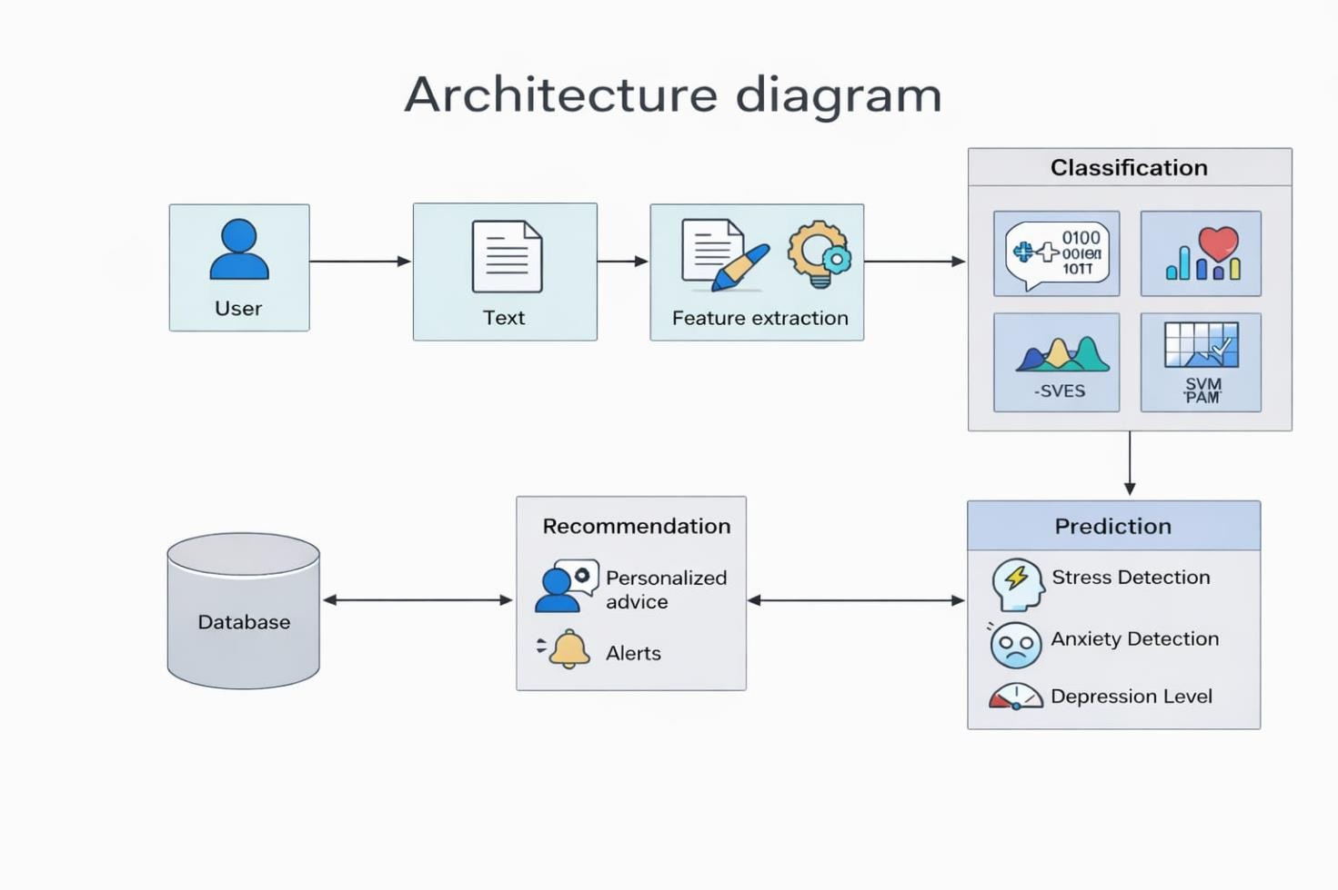

7.2 FLOW CHART

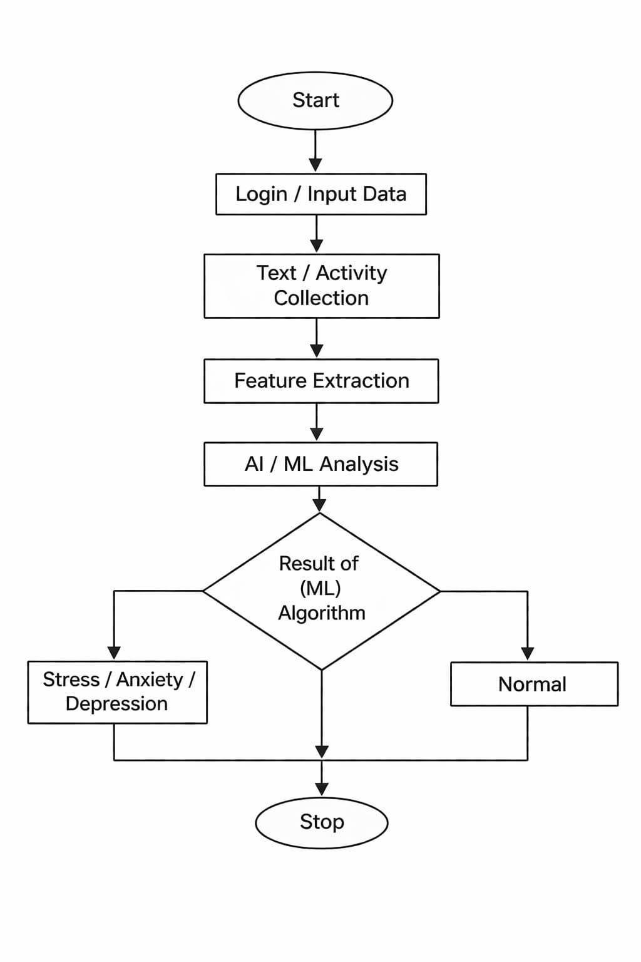

CHAPTER 8
LIST OF FIGURES
8.1 WORK FLOW DIAGRAM
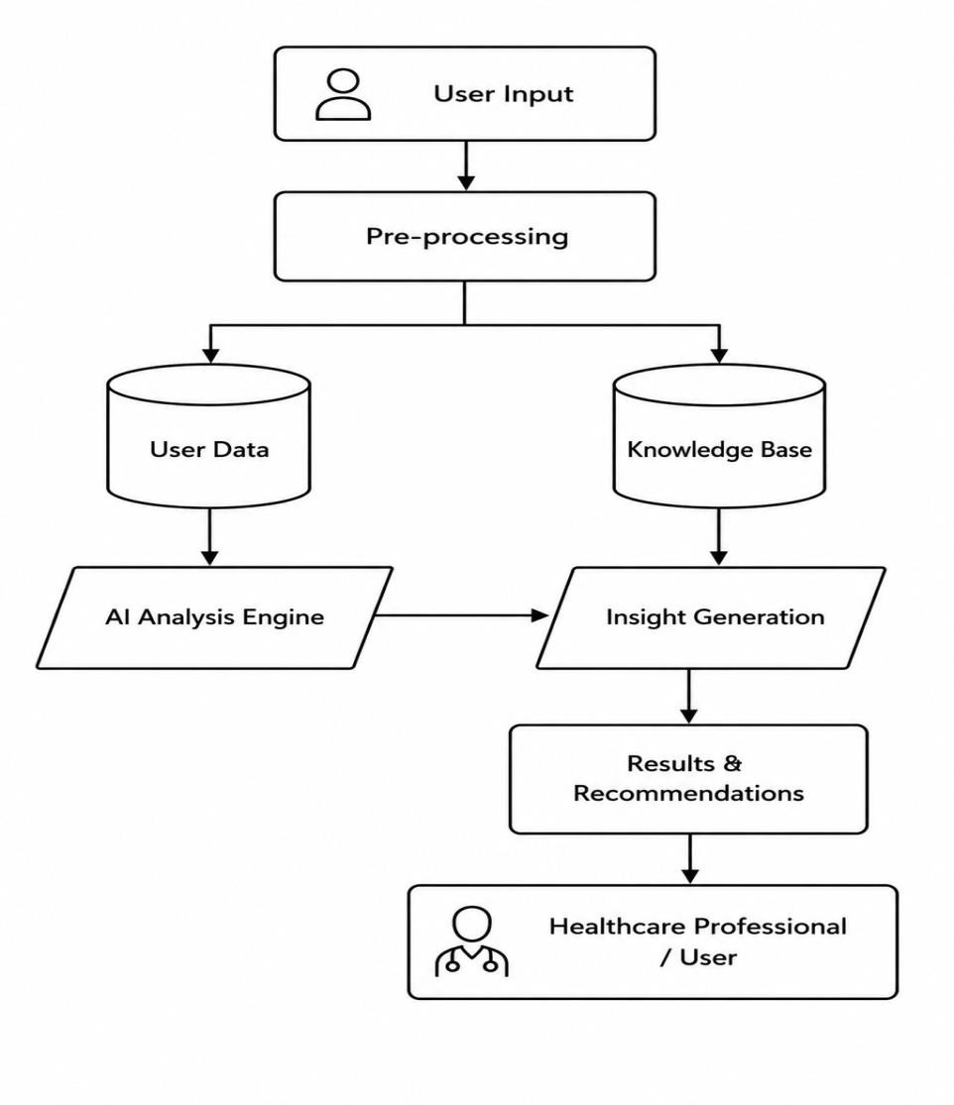

8.2 DATA FLOW DIAGRAM
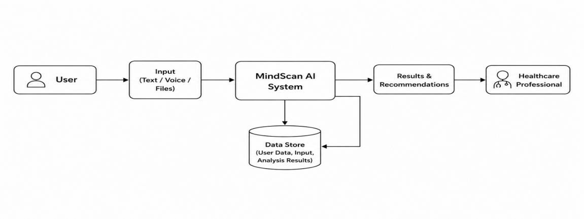

8.3 USECASE DIAGRAM
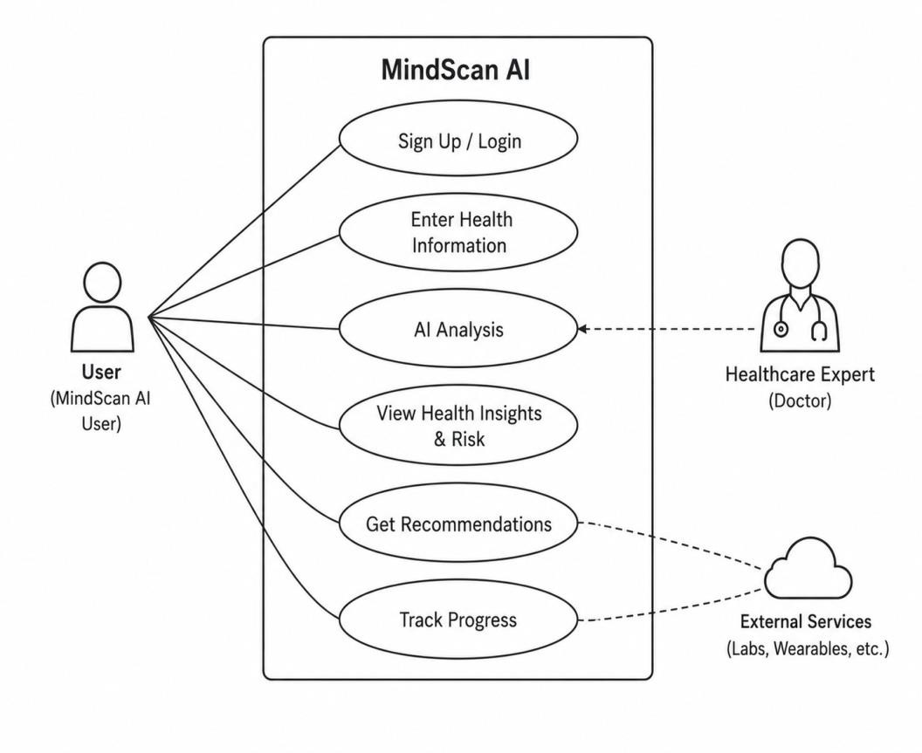

8.4 CLASS DIAGRAM

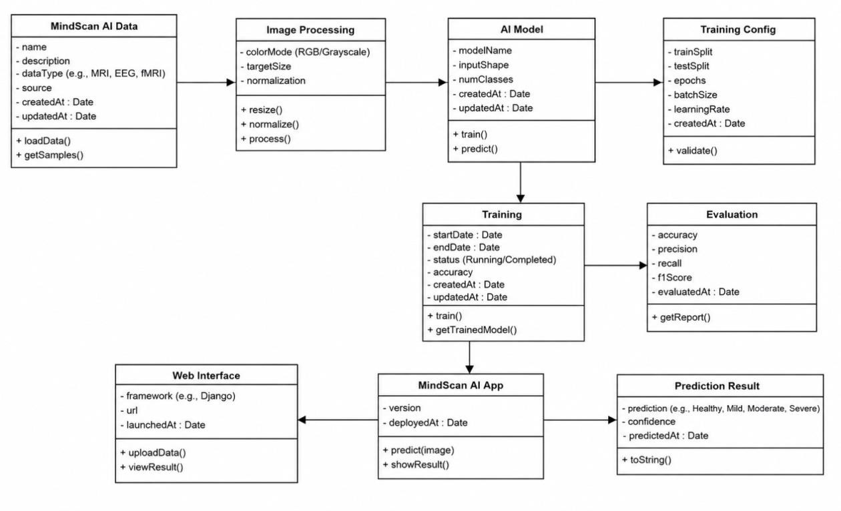

8.5 ACTIVITY DIAGRAM

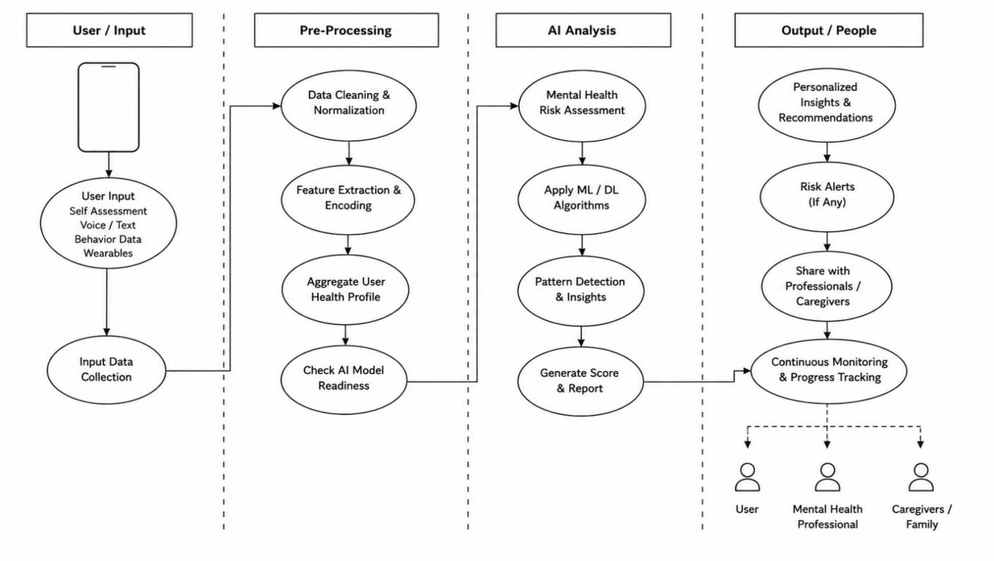

8.6 SEQUENCE DIAGRAM

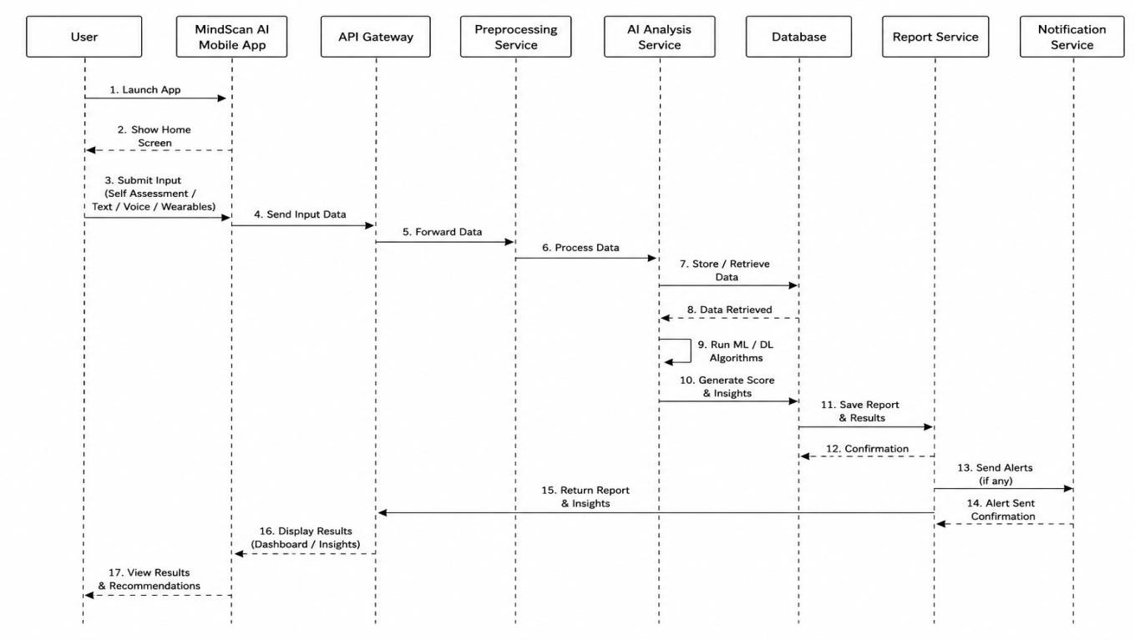

8.7 ER DIAGRAM
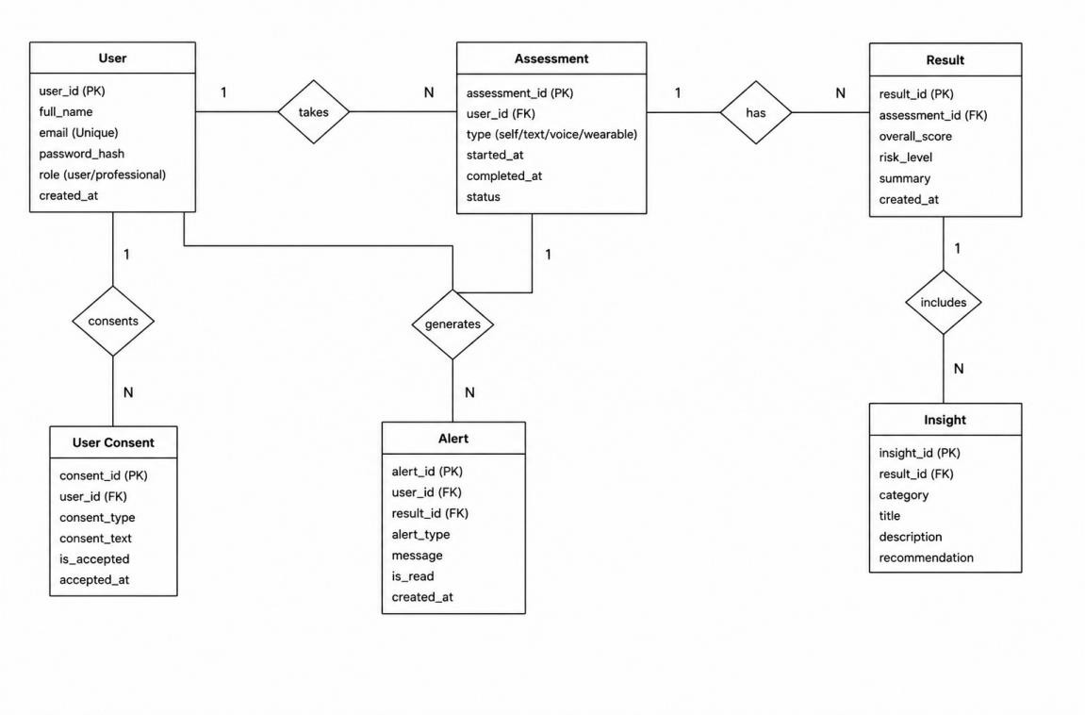

8.8 COLLABORATION DIAGRAM

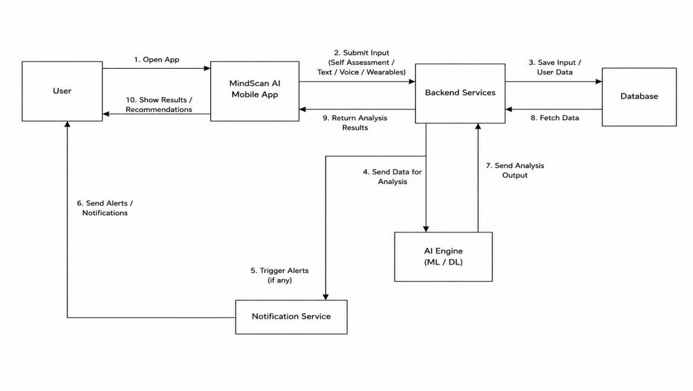

CHAPTER 9
9. MODULES

9.1 USER INTERFACE MODULE
The User Interface (UI) Module is the front end of the system and the first interaction point for users. It provides a simple, clean, and user-friendly design that ensures smooth navigation across the platform. Features include login and registration pages, dashboards displaying mood status, graphs, and reports. The module supports both mobile and web access, maintaining responsive design standards. Clear buttons, menus, and forms reduce confusion, while feedback messages enhance usability. Security is integrated through input validation and error handling. Notifications and reminders are supported, ensuring real-time interaction. Overall, the UI module improves accessibility, usability, and user satisfaction.

9.2 INPUT MODULE
The Input Module is responsible for collecting user data. It accepts personal information, mood logs, questionnaire responses, and self-assessment tests. Inputs can be text-based or voice-based, ensuring flexibility. Validation mechanisms reject invalid data and maintain proper formats, reducing errors in processing. Sensitive information is protected, and privacy standards are followed. The module supports continuous updates, allowing users to edit or modify entries. Structured data is forwarded to the preprocessing module for further analysis. Real-time input collection ensures smooth data flow and reliable performance. Overall, the Input Module is essential for accurate and secure data collection.

9.3 DATA PREPROCESSING MODULE
The Data Preprocessing Module prepares raw data for analysis. It removes noise, errors, and inconsistencies, ensuring data quality. Text cleaning, normalization, and tokenization are applied to standardize inputs. Feature extraction identifies emotional keywords and patterns, while irrelevant data is filtered out. Missing values and outliers are handled to maintain consistency. Preprocessing reduces complexity, improves model accuracy, and ensures structured datasets for AI/ML analysis. It supports multiple data types and connects directly to the AI module. Without preprocessing, results may be inaccurate, making this module a critical step in the workflow.

9.4 AI/ML ANALYSIS MODULE
The AI/ML Analysis Module is the core of the system. It applies Artificial Intelligence and Machine Learning algorithms to processed data, detecting emotional and behavioral patterns. Natural Language Processing (NLP) is used to understand user text and identify hidden meanings. Classification algorithms such as Naïve Bayes, SVM, Logistic Regression, and Random Forest predict mental health conditions like stress, anxiety, and depression. The system adapts over time, learning from new data to improve accuracy. Real-time analysis ensures reliable results, while model evaluation reduces errors. This module acts as the “brain” of the system, providing intelligent insights and continuous improvement.

9.5 PREDICTION MODULE
The Prediction Module interprets outputs from the AI/ML analysis to estimate mental health conditions. It classifies user states, identifies stress levels, and detects depression risks. Predictions are generated quickly and displayed clearly, often with confidence levels. Real-time prediction supports early detection and decision-making. The module connects with the recommendation system to trigger personalized suggestions. It updates continuously with new data, ensuring accuracy and reliability. By reducing uncertainty and improving awareness, the Prediction Module plays a key role in mental health monitoring.

9.6 RECOMMENDATION SYSTEM MODULE
The Recommendation System Module provides personalized suggestions based on predictions and user history. It offers stress management techniques, relaxation methods, meditation guidance, and healthy lifestyle tips. Recommendations adapt to user needs, ensuring relevance and engagement. The system may connect users to external resources such as helplines or counseling support. Positive reinforcement messages encourage motivation and self-care. Regular updates keep suggestions fresh and actionable. This module improves user trust, supports recovery, and enhances overall system usefulness by promoting better mental health practices.

9.7 DATABASE / CLOUD STORAGE MODULE
The Database/Cloud Storage Module manages secure storage of all user data, including profiles, emotional history, activity logs, and prediction results. Cloud storage ensures scalability and availability, while encryption and access controls protect privacy. Backup mechanisms prevent data loss, and logs track errors and user activity. Real-time updates support smooth integration with all modules. The system handles multiple users efficiently, maintaining performance and consistency. Cloud-based solutions reduce maintenance issues and support future growth. Overall, this module is essential for reliability, security, and long-term monitoring in MindScan AI.

CHAPTER 10
10.OUTPUT

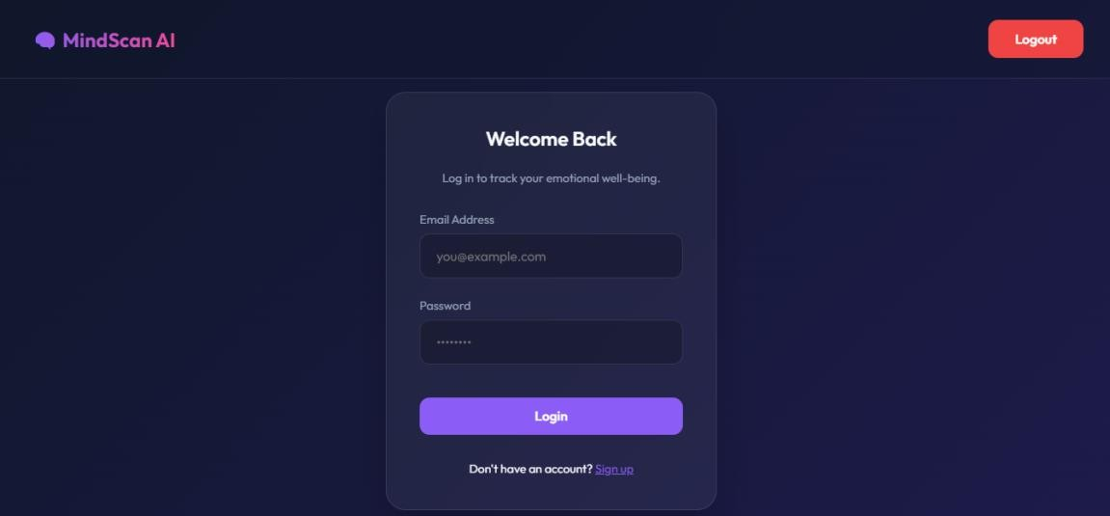

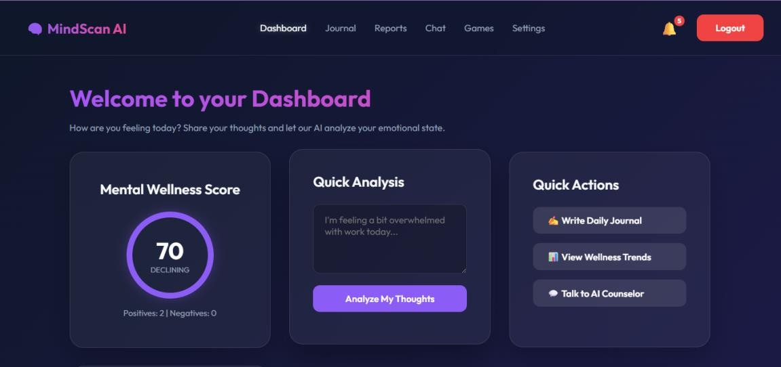

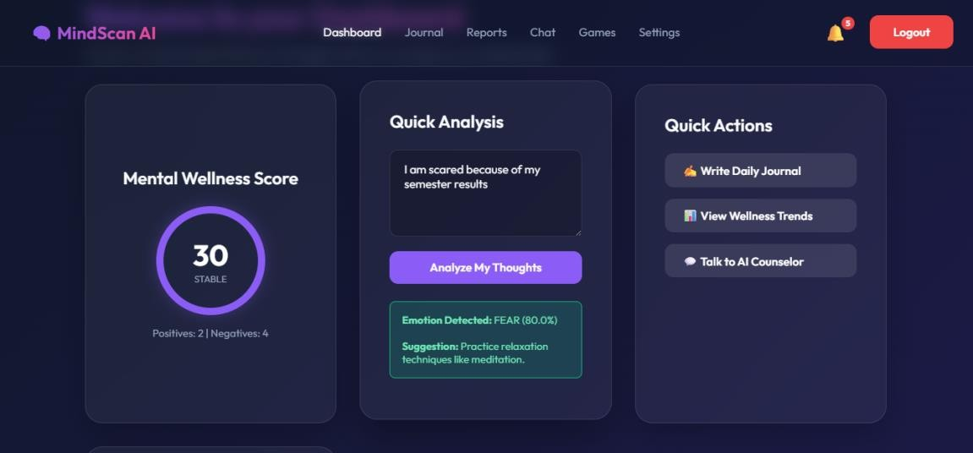

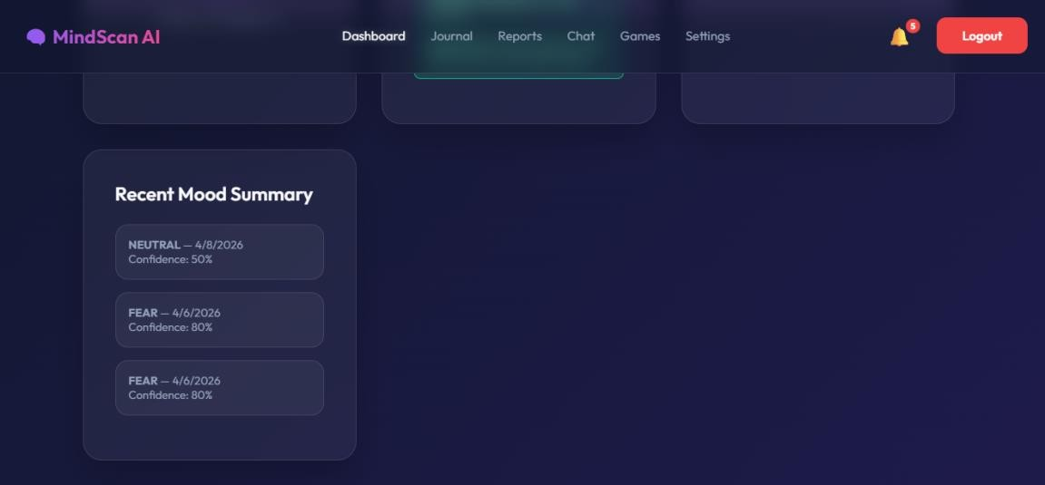
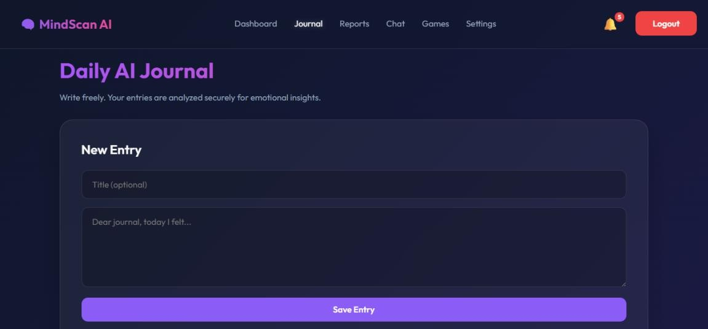
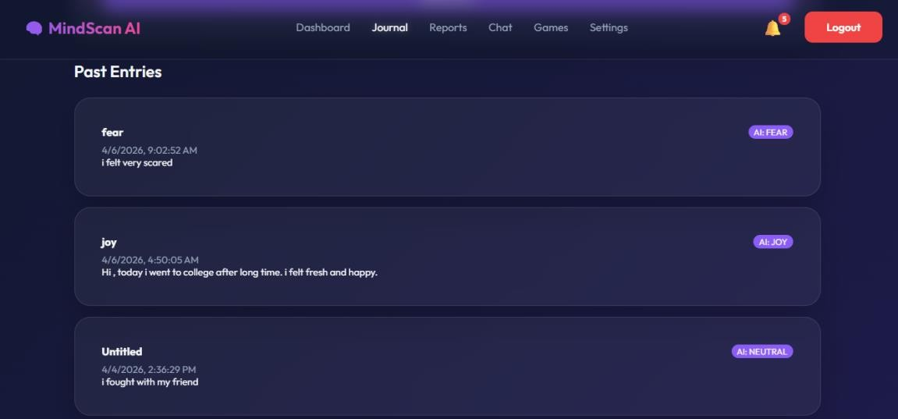
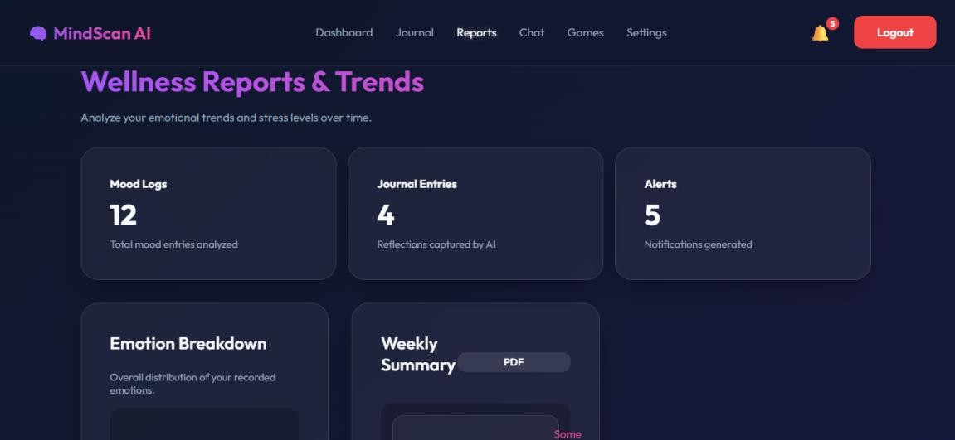
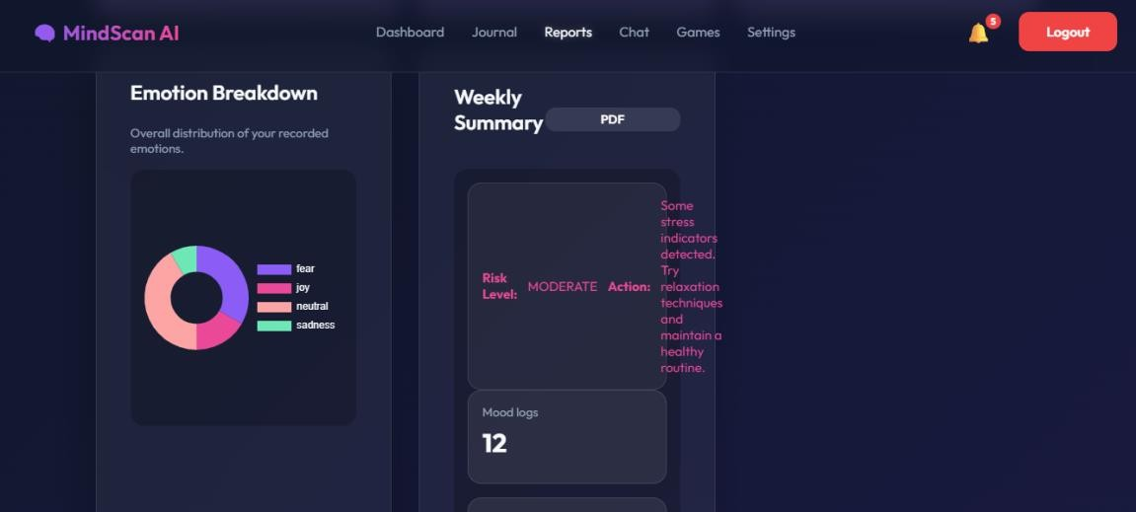
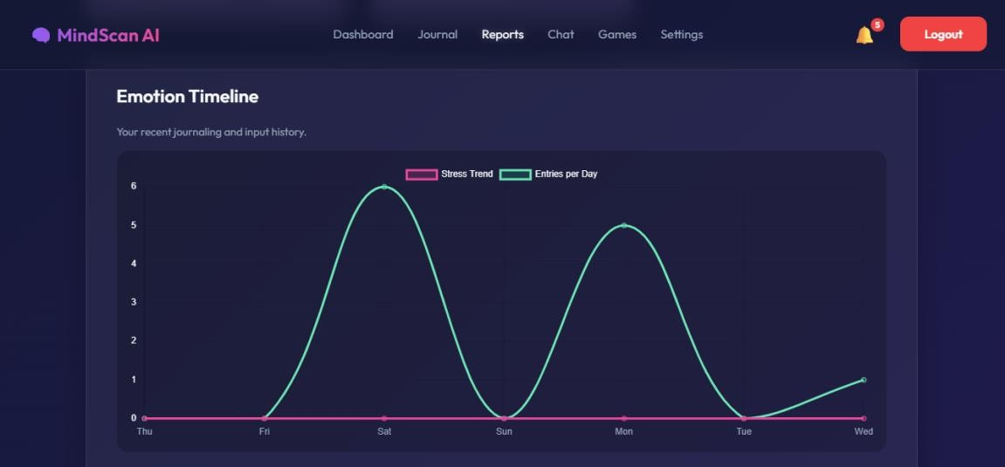
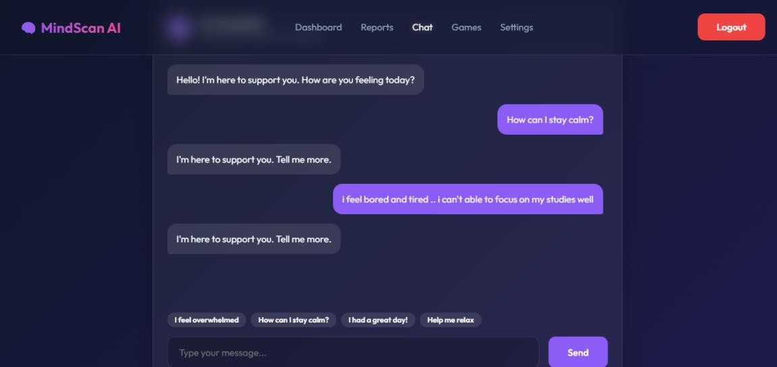
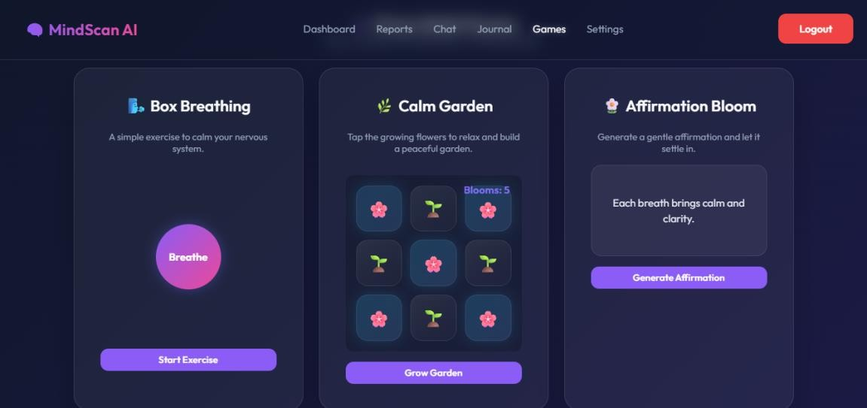
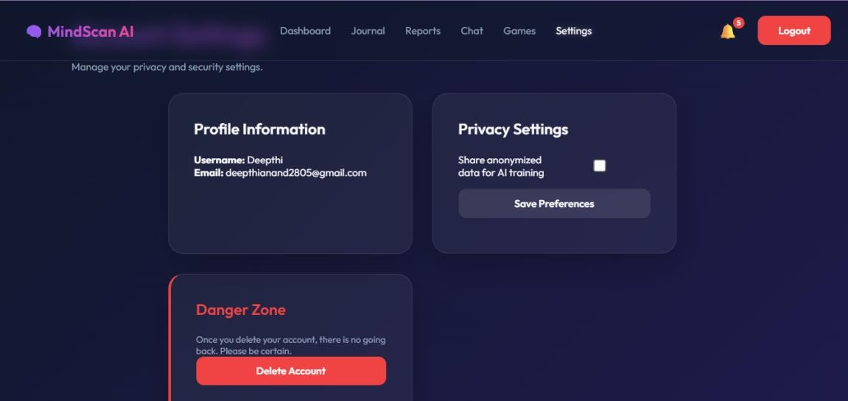

CHAPTER 11

11. CONCLUSION
MindScan AI is an intelligent mental health detection system that uses Artificial Intelligence (AI) and Machine Learning (ML) to provide early identification of stress, anxiety, and depression. The project improves awareness, supports continuous monitoring, and offers personalized suggestions, making it efficient, reliable, and user-friendly. By reducing dependency on manual methods, it enhances decision-making and promotes better mental health care.
Future enhancements can further strengthen the system. Voice and facial analysis can be integrated to improve accuracy, while wearable devices can enable real- time monitoring. Data security and privacy can be enhanced, and multilingual support added for global accessibility. Continuous updates to AI models and clinical integration will make the system smarter and more effective.
Overall, MindScan AI demonstrates great potential in combining psychology and computer science to deliver innovative healthcare solutions. With future developments, it can evolve into a comprehensive tool for improving mental health worldwide.

12. FUTURE ENHANCEMENT
MindScan AI has the potential to evolve into a more intelligent, interactive, and user-centered platform in the future. As technology in artificial intelligence and mental health support continues to grow, several advanced features can be integrated to improve the effectiveness and usability of the system.
One of the major future enhancements is the integration of real-time voice and facial emotion recognition. Currently, the system mainly analyzes textual input, but adding voice tone analysis and facial expression detection can provide more accurate emotional insights. This would help the application understand user emotions more naturally and improve the reliability of emotion prediction.
Another important enhancement is the implementation of personalized mental wellness recommendations. By analyzing user behavior, emotional history, and interaction patterns, the system can provide customized suggestions such as meditation exercises, motivational content, stress management techniques, and daily wellness activities. This personalized approach can improve user engagement and emotional well-being.
MindScan AI can also be enhanced by integrating chatbot-based emotional support. An intelligent conversational assistant can interact with users, provide basic guidance, and offer supportive responses during stressful situations. This feature can make the platform more interactive and accessible at any time.
In the future, the application may include multilingual support to make the platform usable for people from different linguistic backgrounds. This would expand accessibility and allow users to communicate in their preferred language, improving comfort and accuracy during emotional analysis.
Finally, future versions of MindScan AI may collaborate with healthcare professionals and wellness platforms to provide professional mental health support when needed. This integration could help bridge the gap between technology and healthcare, making the system more beneficial for users seeking emotional assistance and mental wellness monitoring.
Overall, these future enhancements can transform MindScan AI into a comprehensive and intelligent emotional health platform that provides accurate analysis, personalized support, and improved user experience.

CHAPTER 10
10.1 APPENDICES
login.html
<!DOCTYPE html>
<html lang="en">
<head>
<meta charset="UTF-8">
<meta name="viewport" content="width=device-width, initial-scale=1.0">
<title>MindScan AI - Login</title>
<link rel="stylesheet" href="/static/style.css">
</head>
<body>
<nav class="navbar">
<h2> MindScan AI</h2>
<div class="auth-buttons" id="auth-buttons">
<a href="/register" class="btn btn-secondary">Register</a>
</div>
</nav>
<div class="main-content">
<div class="glass-card center-form">
<h3>Welcome Back</h3>
<p class="text-muted text-sm" style="margin-bottom: 2rem;">Log in to track your emotional well-being.</p>
<form id="loginForm" onsubmit="event.preventDefault(); login();">
<div class="input-group"> <label>Email Address</label>
<input type="email" placeholder="you@example.com">  </div>  <div class="input-group">  <label>Password</label> | id="email" | required
<input type="password" | id="password" | required
placeholder="••••••••">
</div>
<button type="submit" class="btn mt-1" id="loginBtn">Login</button>
<div id="msg" class="msg-alert"></div>
</form>
<p class="mt-2 text-sm">Don't have an account? <a href="/register" style="color: var(--primary);">Sign up</a></p>
</div>
</div>

<script src="/static/script.js"></script>
<script>
async function login() { const btn = document.getElementById("loginBtn"); const email = document.getElementById("email").value; const password = document.getElementById("password").value;
btn.innerHTML = '<span class="spinner"></span> Logging in...'; btn.disabled = true;
try {
const res = await fetch(`${API_BASE}/auth/login`, { method: "POST", headers: { "Content-Type": "application/json" }, body: JSON.stringify({ email, password })
});
const data = await res.json(); if (res.ok && data.access_token) { localStorage.setItem("token", data.access_token); window.location.href = "/dashboard";
} else { showAlert("msg", data.message || "Invalid credentials", "error");
}
} catch (error) { showAlert("msg", "Server connection failed.", "error"); } finally { btn.innerHTML = 'Login'; btn.disabled = false;
}
}
</script>
</body>
</html>
app.py
from flask import Flask, render_template from config import Config from models import db from auth import auth_bp from analysis import analysis_bp from flask_jwt_extended import JWTManager from flask_cors import CORS
app = Flask(__name__) CORS(app) app.config.from_object(Config) app.config["JWT_SECRET_KEY"] = "super-secret-key"
db.init_app(app) jwt = JWTManager(app)
app.register_blueprint(auth_bp, url_prefix="/auth") app.register_blueprint(analysis_bp, url_prefix="/analysis")
@app.route("/") def root():
return render_template("login.html")
@app.route("/login") def login():
return render_template("login.html")

@app.route("/register") def register():
return render_template("register.html")
@app.route("/dashboard") def dashboard():
return render_template("dashboard.html") @app.route("/report") def report():
return render_template("report.html")
@app.route("/chatbot") def chatbot():
return render_template("chatbot.html")
@app.route("/journal") def journal():
return render_template("journal.html")
@app.route("/settings") def settings():
return render_template("settings.html")
@app.route("/games") def games():
return render_template("games.html") if __name__ == "__main__": with app.app_context(): db.create_all()
app.run(debug=True)

REFERENCES

1. Zhong & Wang, "Intelligent depression Prevention via LLM-Based Dialogue Analysis",
2025
2. Ahmed et al., "Explainable AI for Depression Detection From Activity Data", 2025.
3. Zhao et al., "Multi-Modal LLM for Depression Detection", 2025.
4. Wang & Wu, "Advances in AI-Based Depression Diagnosis: Systematic Review", 2025.
5. Chlasta, "AI-Based Screening Through Eye Tracking", 2025.
6. G. D. Jadhav, S. D. Babar, and P. N. Mahalle, "Comparison for Early Depression
Detection," 2024 IEEE 4th International Conference on ICT in Business Industry &
Government (ICTBIG), Pune, India, 2024.
7. T. Nijhawan et al., "Stress detection using natural language processing and machine
learning over social interactions," Journal of Big Data, vol. 9, no. 33, 2022.
8. A. K. S., "Anxiety and Depression Detection using Machine Learning," 2022 International
Conference on Machine Learning, Big Data, Cloud and Parallel Computing
(COM-IT-CON),. 2022.
9. R. Kumar et al., "A Review Paper: Accuracy of Machine Learning for Depression and
Detection in Social Media," 2022 IEEE International Conference on Communication,
Networks Satellite (COMNETSAT), 2022.
10. M. S. A., "Machine Learning Models based Mental Health Detection," 2022 Third
International Conference on Intelligent Computing Instrumentation and Control
Technologie (ICICICT), 2022.
11. P. S., "Effective Machine Learning Based Techniques for Predicting Depression," 2022
IEEE International Conference, 2022.
12. "Early stress detection using natural language processing and machine learning,"
International Journal of Scientific Research (IJSR), Jan 2024.
13. "Mental health detection using sentiment analysis," World Journal of Advanced Research
and Reviews, vol. 30, no. 1, pp. 1094-1102, 2026.
14. A. Pak and P. Paroubek, "Twitter as a Corpus for Sentiment Analysis and Opinion Mining,"
Proceedings of the Seventh International Conference on Language Resources and
Evaluation (LREC'10), 2010.
15. A. Agarwal et al., "Sentiment Analysis of Twitter Data," Proceedings of the Workshop on
Language in Social Media (LSM), 2011.
16. M. De Choudhury, M. Gamon, S. Counts, and E. Horvitz, "Predicting Depression via
Social Media," Proceedings of the International AAAI Conference on Web and Social
Media (ICWSM), 2013.
17. G. Coppersmith, M. Dredze, and C. Harman, "Quantifying Mental Health Signals in
Twitter," Proceedings of the Workshop on Computational Linguistics and Clinical
Psychology, 2014.
18. S. Tsugawa et al., "Recognizing Depression from Twitter Activity," Proceedings of the 33rd
Annual ACM Conference on Human Factors in Computing Systems, 2015.
19. Jin, Lai, and Cao, "BERT and modified TF-IDF for multi-label sentiment analysis," IEEE
Access, 2020.
20. J. Smith et al., "Predictive Analytics for Mental Wellness using Wearable Sensors and
Machine Learning," IEEE Internet of Things Journal, 2023.

